Spooky Night by Marie-Lou Denis
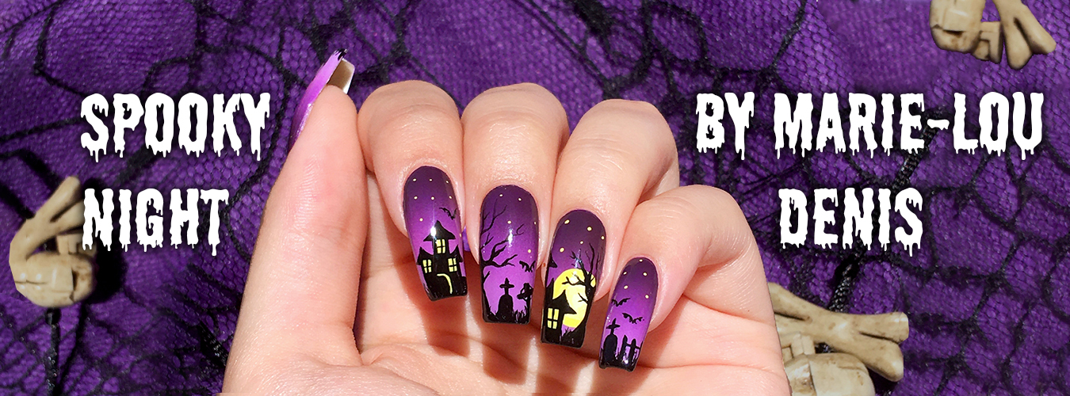
By Marie-Lou Denis
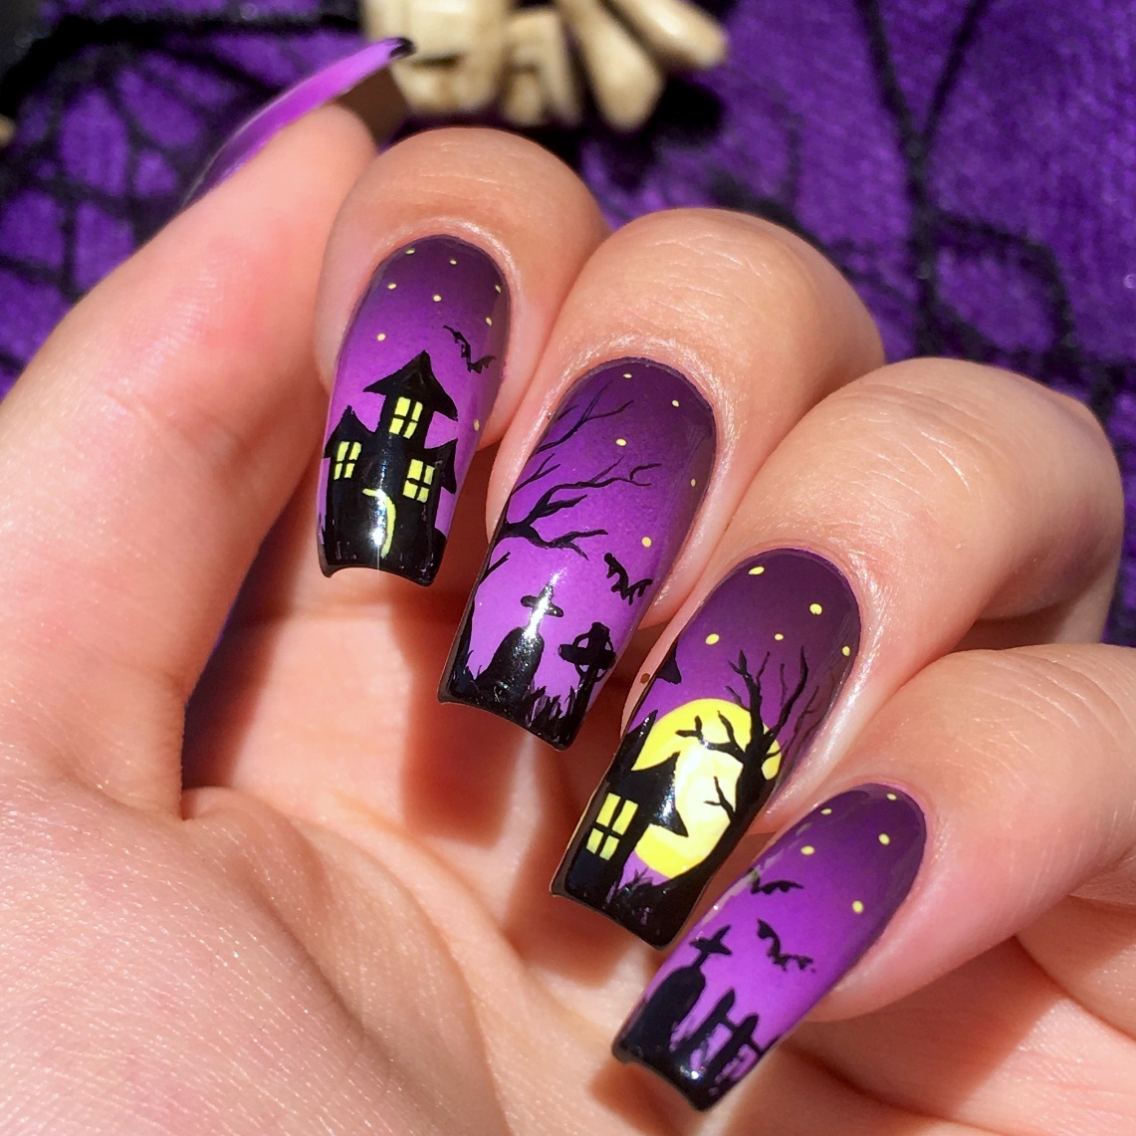

Surface
Your natural nails or nude press one nails. You can get those at Sally’s beauty.

Palette
Decoart Americana acrylic paint:
- DA011 Lemon Yellow
- DA067 Lamp (Ebony) Black
- DA240 Cool White
- DA101 Dioxazine Purple
- DA140 Red Violet
- DA302 Purple Pizzazz
- DA233 Wild Orchid

Brushes
- Princeton Select Short Liner 18/0
- Princeton Select Flat shader #6
- Princeton Select Angular shader ¼”

Other materials
- Paper palette
- White Makeup sponge
- White nail polish
- Base & Top coat
- Dotting tool
- Acetone

Preparation
Start off by washing your hands thoroughly. Then either apply your press on nails or your base coat nail polish. Let it dry fully and apply 2 coats of your white nail polish.

Directions
- Gradient: For the dark purple use the following mix Dioxazine Purple + Red Violet (1:1)

  - Apply your dark purple mix, Purple Pizzazz & Wild Orchid to your makeup sponge with a Flat shader #6.

  - Dab it on your nails while doing an up and down motion to blend out the colors. Repeat this until you reach full opacity and the gradient is well blended.

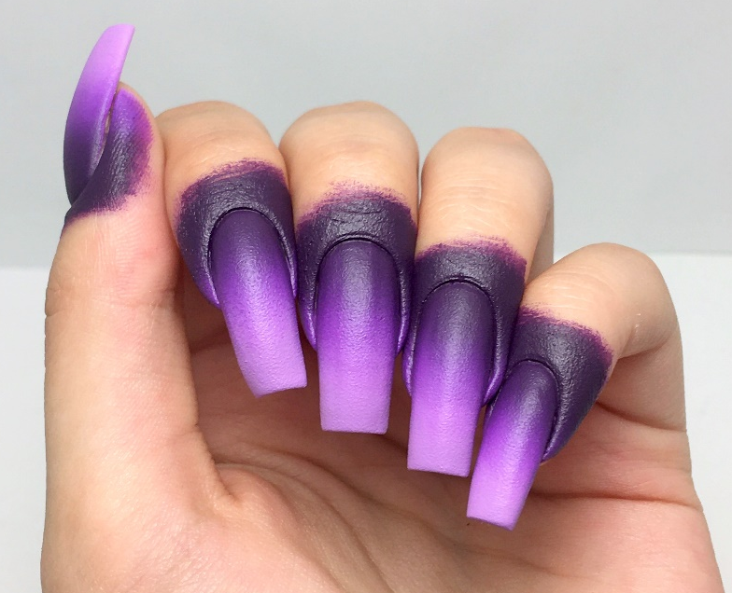

  - Apply a quick dry top coat to seal in the gradient.

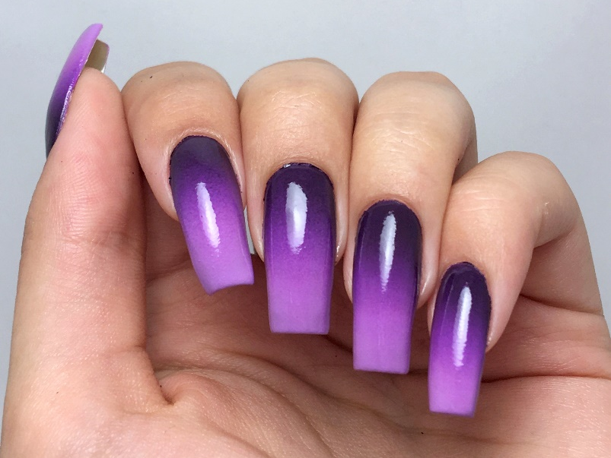

  - Remove the paint on your skin by washing your hands and rubbing gently.

- Grass: Use the short liner 18/0 to paint the grass with Lamp (Ebony) Black.

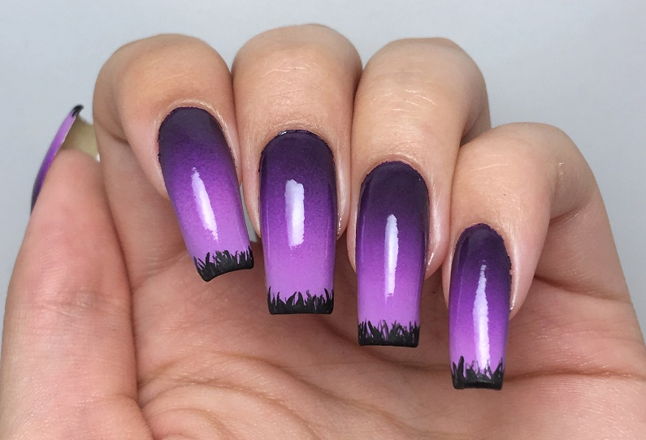

- Moon: Paint a circle for the moon in Cool White with the short liner 18/0.
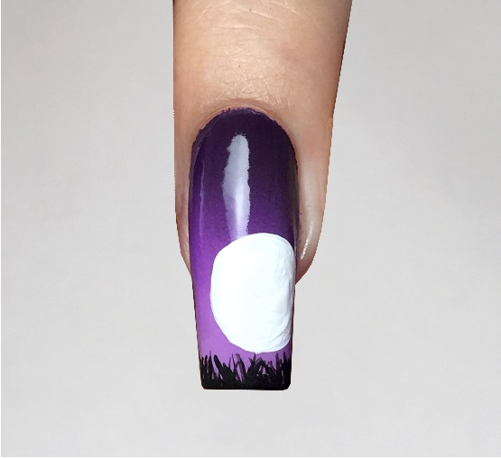

  - Shade with Lemon Yellow and the angular shader ¼”.
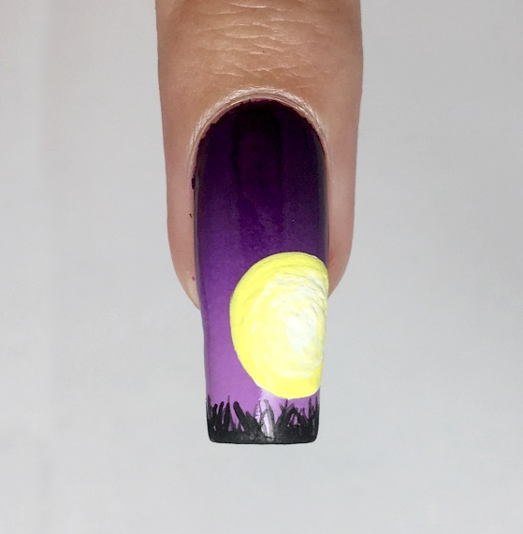

- Haunted house: Paint the haunted house and the tree with Lamp (Ebony) Black and your short liner 18/0.
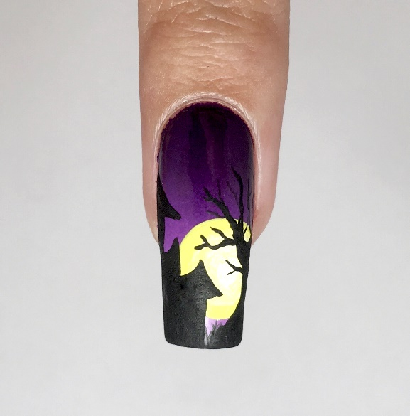

- Paint the windows with Lemon Yellow and paint the window bars with Lamp (Ebony) Black doing a cross like shape with your short liner 18/0.
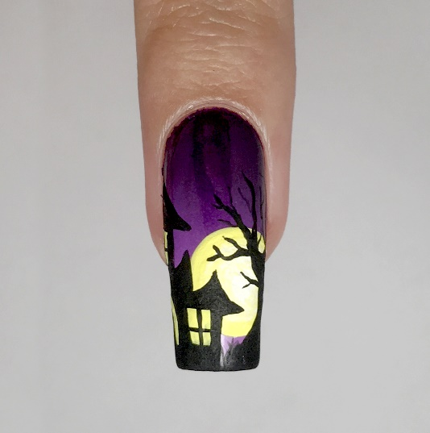
- Thumb: Paint a tree, a fence & a bat in Lamp (Ebony) Black with your short liner 18/0.
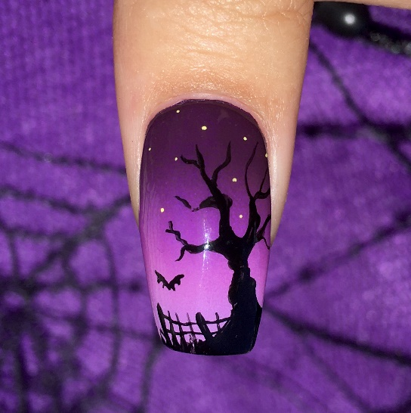

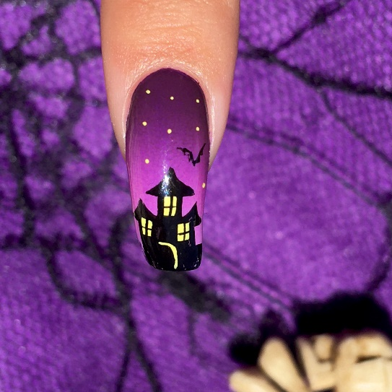
- Pointer: Repeat the same steps for the haunted house and paint a bat in Lamp (Ebony) Black with your short liner 18/0.

- Middle finger: Use Lamp (Ebony) Black to paint a tree and tombstones with crosses on top. Paint a bat too. All with your short liner 18/0.
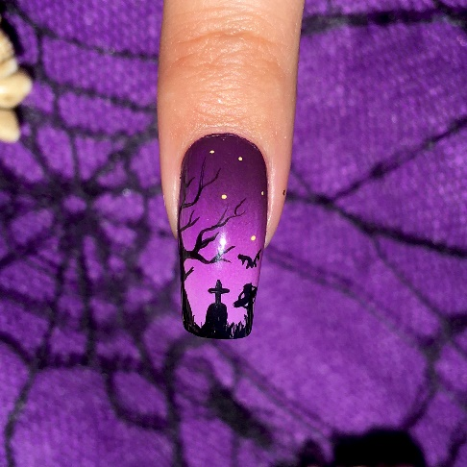

- Pinky: As for step #7, paint tombstones. Paint a fence and bats too using Lamp (Ebony) Black with your short liner 18/0.
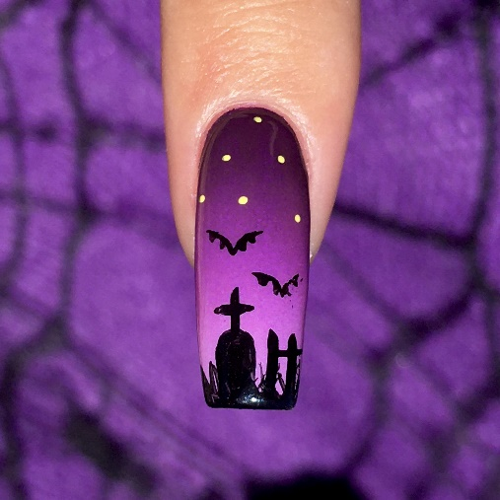

- Sky: Paint stars with Lemon Yellow and either your short liner 18/0 or a dotting tool.
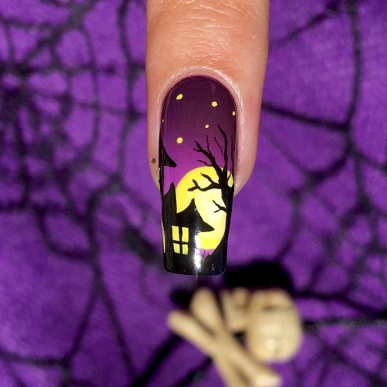

Finish
Apply your final quick dry top coat, you may need 2 coats. If you accidently got some nail polish on your skin, use your Loew Cornell Angular brush ¼ dipped in acetone (or nail polish remover) and clean up your cuticles.
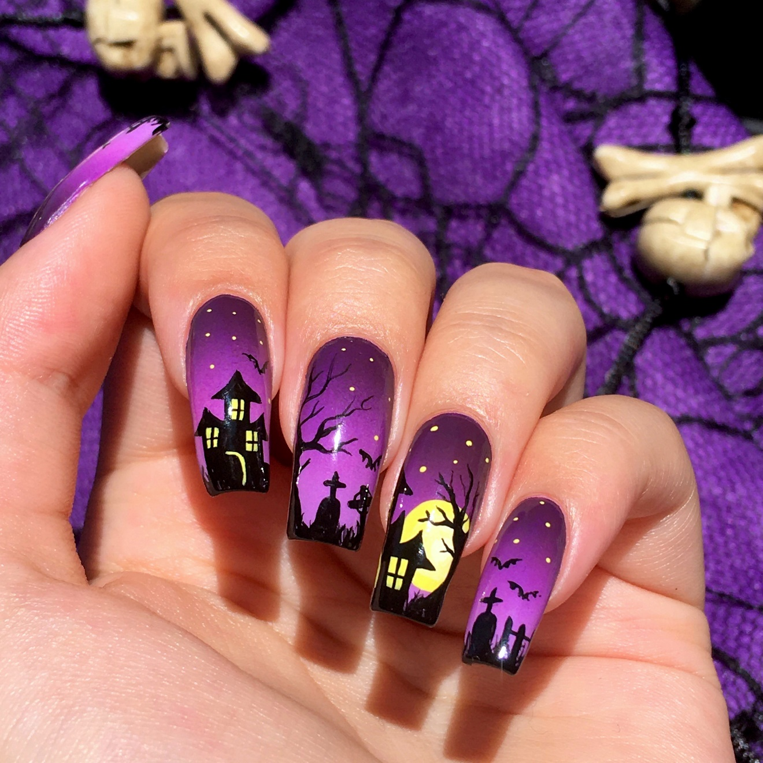

I hope you enjoyed painting this spooky night on your nails! You can share it with me on my Instagram : https://www.instagram.com/nailing_painting/ , Facebook: https://www.facebook.com/nailingpainting or Twitter: https://twitter.com/NailingPainting
©2020 Nailing Painting

