BY THE SEA CARRIER from Dollar Tree materials
By Margaret Riley
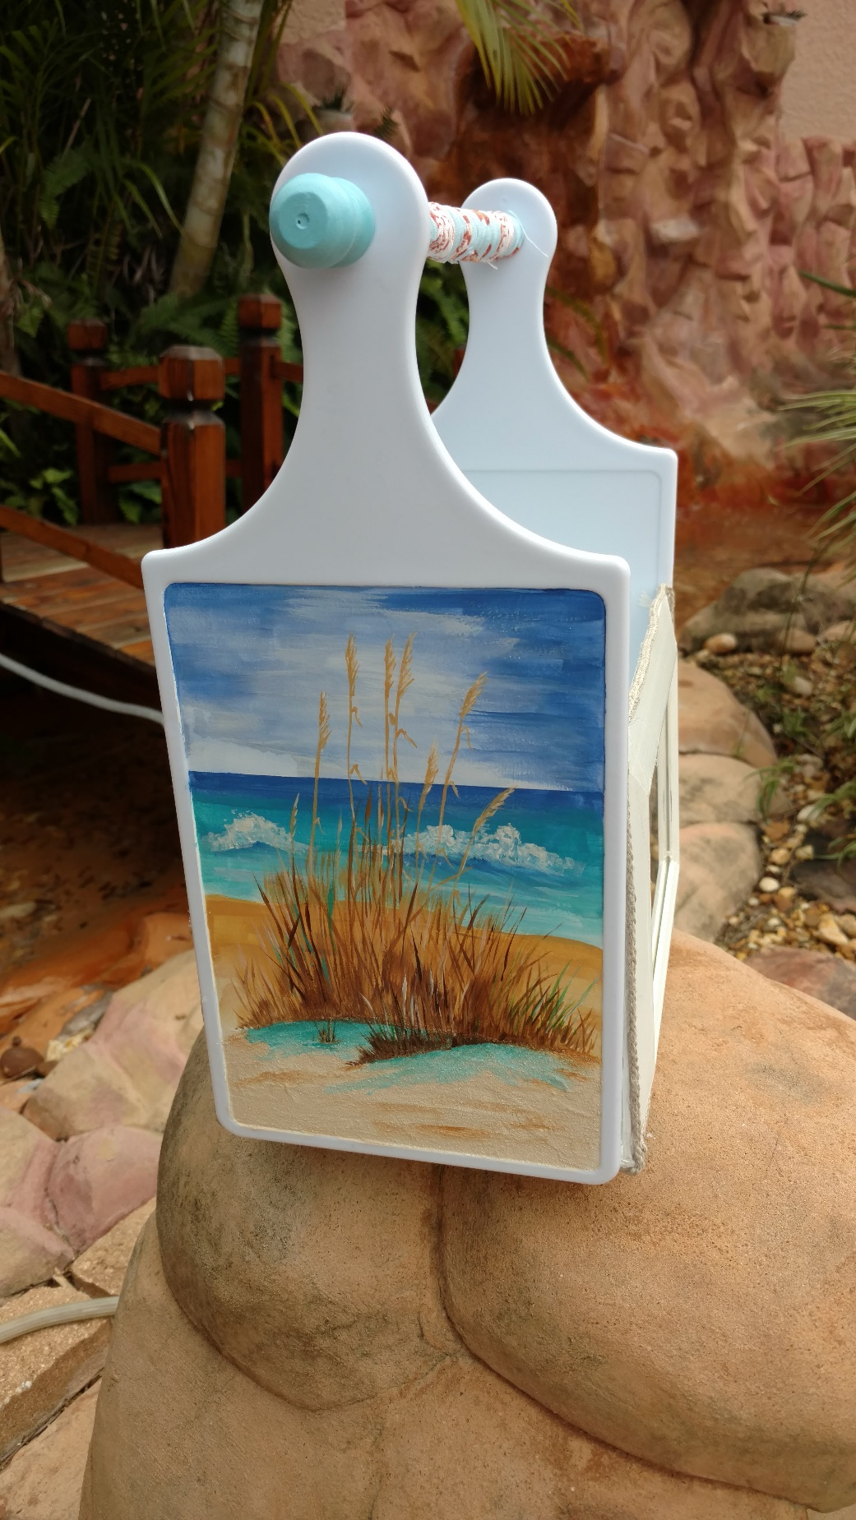
Looking for a cheap surface to paint on? Just roam your local Dollar Tree store. Even these items can be found in a Dollar General store. With a little glue and paint, you can have a great gift for a special occasion. In the frames, you can use favorite photos, do a painting, or even a colorful piece of fabric. This is a great napkin holder, too. Or maybe place two small potted herbs in the carrier, add a bow, and it’s ready for gift giving. No matter what you chose, the basic items for this project will give you great satisfaction in a finished project.

SUPPLIES

SURFACE
2) Small plastic cutting boards (approximate size 5-3/4” x 12-1/2”)
3) 5” x 7” plastic or wood frames
2) 4” x 6” lightweight watercolor paper

PAINTS
DecoArt Americana Acrylic Paints
Camel
Dark Chocolate
Honey Brown
Laguna
Light Mocha
Mistletoe
Sapphire
White Wash

BRUSHES
Royal & Langnickel Soft Grip
Shader SG150 Nos. 4, 8, and 12 or Angular SG160 Nos. 1/4", 1/2”, 1”
Round SG250 Nos. 4 and 8
Short Liner SG595 Nos. 20/0 and 2
1” sponge brush
Old #4 flat brush (bristle should be fanning out from brush, or use a very small fan brush)

OTHER
Tracing paper and pencil
Transparent tape (to secure tracing paper from moving)
Graphite (gray or black)
Red ink pen (to trace pattern to surfaces)
Water basin
Palette
Paper towel
Matte Varnish Spray
10” dowel (1/2” thickness…measure hole on cutting board to be sure dowel goes through)
Fusion Glue by I Love to Create
Hot glue gun and glue sticks
Optional: 30” burlap cording
Optional: Fabric to cover dowel (if gathering on fabric, will need 2-3/4” x 20”)
2) Wood candle cups that will fit on dowel ends

INSTRUCTIONS

Notes:
Use brushes to accommodate the area.
Fabric can be used on the dowel handle or the dowel can be painted.
Read preparation section before starting.

PREPARATION
No need to pre-paint the cutting boards if they are white plastic. But spray them with a matte varnish so paint will adhere better.
Paint frames in color of choice without backing and glass inserted. It may take 3-4 coats of paint if using white over a wood-colored frame. Or frames can be spray painted instead of using the brush-on technique.
Assembly of the carrier can be done before painting the design OR you can paint design first and then assemble.
Trace pattern by taping the top of pattern to surface, slip graphite between surface and pattern, and use red ink to trace pattern. Enlarge pattern, if needed.

SEA VIEW
1. Paint sky Sapphire and White Wash blending the colors softly together and keeping white at the horizon line. Be more prominent in middle of sky for distant clouds.
2. Starting at the horizon line, paint the ocean in Sapphire and for 1/2” then start blending in Laguna. Continue to edge of sand. Tap in White Wash waves with Sapphire shading under each wave.
3. Starting at water edge, paint downward with Camel and continue blending downward in Honey Brown until reaching the sea oats base.
4. On palette, mix Texture Sand Paste with Light Mocha. Spread this mixture from sea oats to bottom of surface.
5. Paint Laguna at the base of the sea oats referring to photo for placement.
6. Add some streaks of Honey Brown and White Wash into sand.
7. Using liner brush, paint blades of grass in Honey Brown, adding shadowing blades of grass in Dark Chocolate.
8. Add some Light Mocha and Camel randomly on blades of sea oats grass.
9. Here and there, add some touches of Mistletoe.
10. Light Mocha can be used for highlights.
11. Using old #4 brush or a fan brush, add some Dark Chocolate at the base of sea oats pulling paint up from sand.

ASSEMBLY
Stand up the cutting boards with one frame butted up to the bottom of each board to be sure frame will fit comfortably.
Apply Fusion glue every other 1” along the bottom of the cutting board, then fill in the empty spaces with hot glue. The fusion will be more “gripping” to the two surfaces, while the hot glue adheres quickly with no waiting for a glue to set up.
Quickly adhere the bottom of the glued cutting board with a 5” edge of one frame.
Repeat for the other end of the frame, adhering the other cutting board to the frame.
Apply glues to three sides of the second frame and adhere it to one side of the carrier.
Repeat with the third frame on the opposite side.
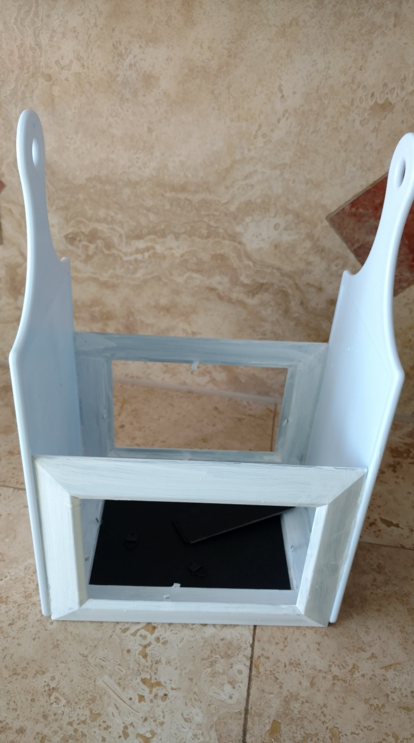

FINISHING
If desired, glue on burlap cording to cover any small gaps and hot glue showing around side frames.
Sew together long side of fabric with 1/4" seam on wrong side. Sheer this onto dowel.
Place dowel into hole on one end and into opposite hole on “cutting board”.
Paint candle cups desired color. Let dry.
Place candle cup at each end of dowel. If candle cups are loose, add a drop of glue to secure in place.
