LOVE BIRDS
By Pamela Cassidy

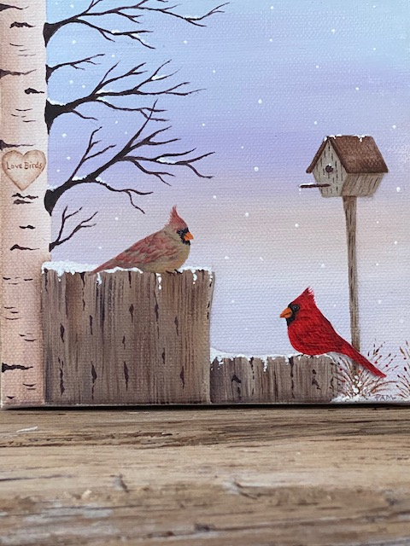
Cardinals are beautiful songbirds who often choose their mates for life. With Valentine’s Day just around the corner, this project would be fun to paint for someone special in your life or maybe just for yourself. While this was done on a canvas, it could easily be adapted to another surface of your choice. I hope you have fun painting this happy couple!

I began painting over 15 years ago. As a busy mom of three young boys, I craved a little time to myself and began taking decorative painting classes. I primarily paint with acrylics, but I also enjoy working with oils; and recently, I’ve discovered that watercolors can be fun too. I continue to learn from and be humbled by so many talented artists and gifted instructors. It’s very exciting to now create my own designs and share them with you.

SUPPLIES
Artist’s Loft, 6x6 Back-Stapled Traditional Canvas, Level 1, available at Michael’s
(in-store and on-line)

PAINTS
DECOART AMERICANA
Antique Gold DA09
Blue Chiffon DA193
Brilliant Red DA145
Burnt Umber DA064
Canyon Orange DA238
Cool White DA240
Driftwood DA171
Flesh tone DA078
Khaki Tan DA173
Lamp Black DA067
Natural Buff DA311
Raw Sienna DA093
Soft Black DA155
Wisteria DA211

MEDIUMS
Folk Art Blending Gel #867
Liberty Art Acrylic Matte Varnish, #LS28550

BRUSHES
Royal & Langnickel Zen ¾” Angle Shader
Artist’s Loft Vienna 3/8” Angle Shader
Loew-Cornell 7400C ¼” Angle Shader
Artist’s Loft Vienna 2 Round
Artist’s Loft Vienna 0 Round
Loew-Cornell ¼” Filbert Rake 7520
Master’s Touch ½” Oval Mop 425

MISCELLANEOUS SUPPLIES
Tracing Paper
Black Graphite Paper
Pencil
Paper Towels
Stylus
Palette Paper
Hair Dryer (optional)
Practice Surface (optional)

HELPFUL HINT
It might be helpful to have a practice surface for this project. I recommend this because you may want to practice techniques using the Blending Gel before working directly on your surface. It may also be helpful to practice the small floats on the bird feathers.

INSTRUCTIONS
1. Trace pattern onto tracing paper.
2. Before transferring your pattern, let’s paint the background sky. The sky will be painted using Blue Chiffon, Wisteria, Fleshtone & Cool White. Using the ¾” angle, pick up blending gel on the tip of your brush. Starting with Blue Chiffon at the top of the canvas, begin applying paint in horizontal strokes. Paint about ¼ of the way down the canvas, then pick up some additional blending gel and Wisteria, blend colors where they meet so there are no hard lines and come down again to the half way mark. Continue in the same manner with Fleshtone, and then Cool White to finish. By using the Blending Gel, you can continue to add color and blend until you get a background to your liking. Do not overuse the Blending Gel as it will cause your paint to be too watery. If the colors are too harsh, you can add a little Cool White to your brush to tone them down. The end result should be a soft winter sky, with subtle, gradual changes in color. Dry thoroughly with a hair dryer.

3. Using graphite paper and a stylus, transfer the birch tree and the two tree stumps. You will transfer the tree markings later.
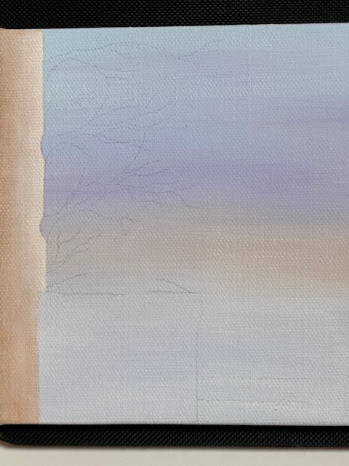
4. Base the birch tree using the 3/8” Angle and Natural Buff. Dry. Using the same brush and Burnt Umber, float a shade on the left side of the tree from top to bottom, and on the right side behind the tree stump. Use the Oval Mop to soften your floats if necessary to avoid hard lines. Using the same brush, float a highlight with Cool White on the right side of the birch tree stopping at the top of the tree stump, using the mop to soften.

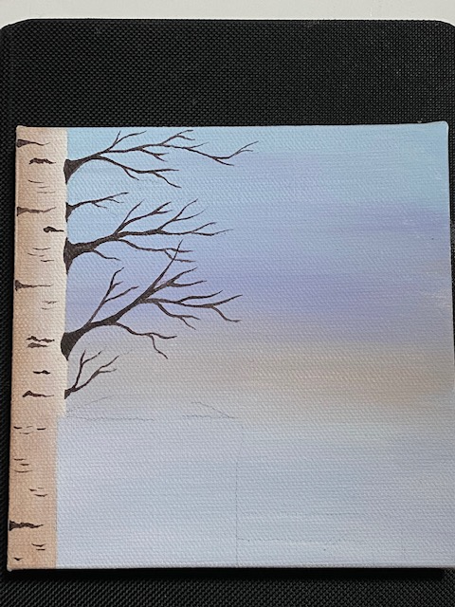
5. Once the birch tree is completely dry, you can transfer on the tree markings. Using the #2 Round and # 0 Round, base the birch branches and markings in Soft Black.

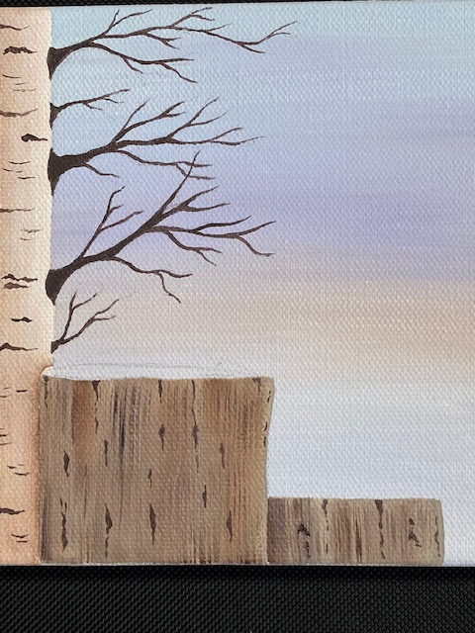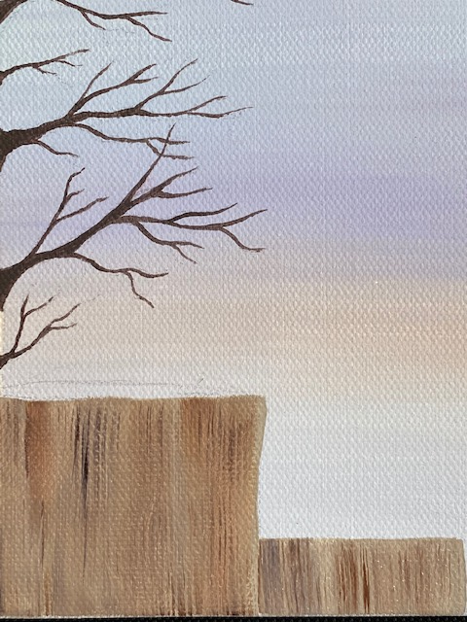
6. Base the tree stumps using the 3/8” Angle and Driftwood mixed with a small amount of Blending Gel. While the Driftwood is still wet, using a dirty brush, randomly pull in vertical strokes of Burnt Umber, Raw Sienna, and Khaki Tan. You do not want stripes. The Blending Gel will help soften the colors to achieve the look of old wood. Using the ¼” Filbert Rake and thinned Burnt Umber, pull in some vertical markings and lines on the tree stumps. Do this randomly and not uniform. Add some additional markings with Soft Black using the #0 Round. Dry.

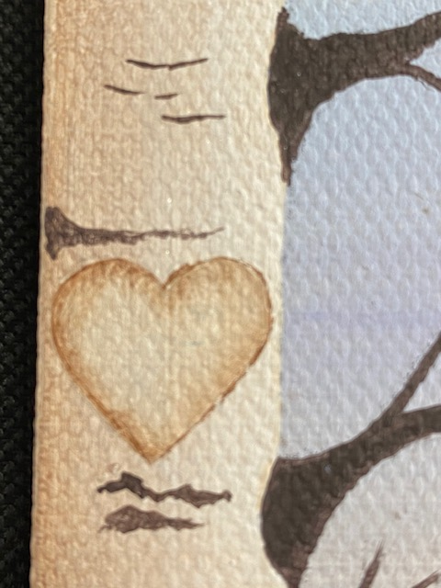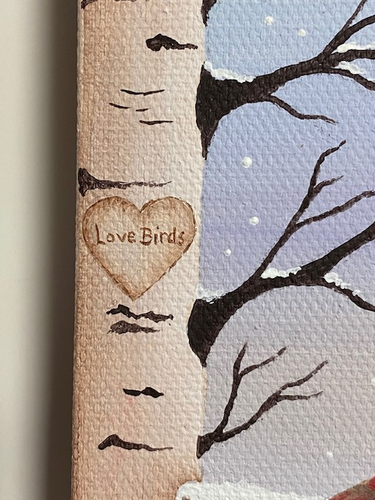
7. Transfer the outline of the heart onto the birch tree. Base the heart with Natural Buff using the #2 Round. Once dry, using the ¼” Angle, float a shade on the interior of the heart with Burnt Umber. The lettering and outline of the heart are done with the 0 Round and Burnt Umber.

8. Using Cool White and the #2 Round, add the snow to the top of the tree stumps and randomly to the branches of the birch. Dry.

9. Transfer in the main outlines of both birds and the birdhouse.

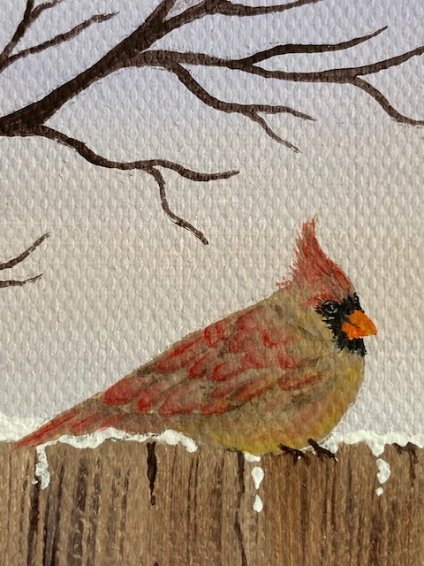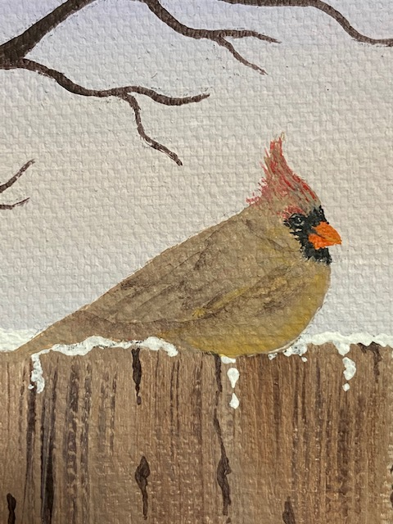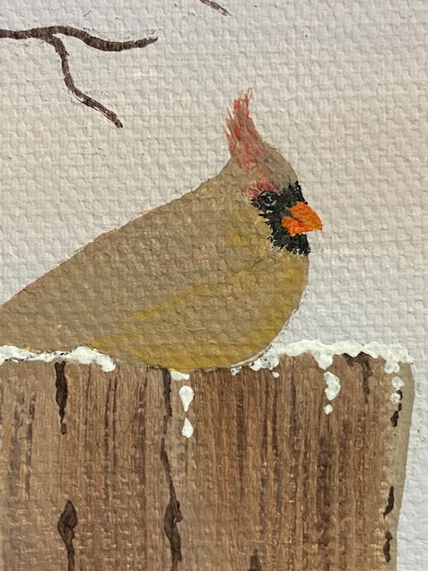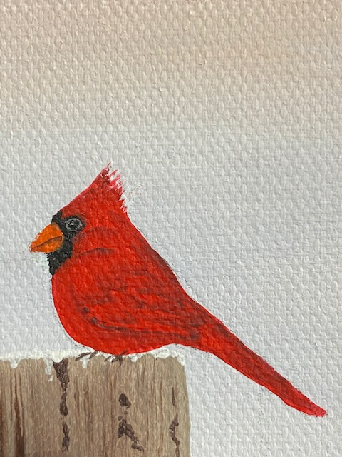
10. Base the female cardinal Khaki Tan and the male Brilliant Red. Transfer in the details on each bird. Both bird markings are painted the same, but with a variation of color. Starting with the female, float a highlight of Antique Gold on the belly using the ¼” Angle. Using the #0 Round base the beak in Canyon Orange, and add the line in the beak, the black mask and the throat with Lamp Black. Using the same brush, pull soft feathery lines with Khaki Tan to detail the crest at the top of the female’s head. Outline the eye with Driftwood, and add a very slight highlight in the center of the eye. Using the ¼” Angle and Soft Black, float a shadow underneath the wing, outline the feathers with small C-shape strokes, float in other markings. Using the same brush and Brilliant Red, float color onto the tail. Starting at the left bottom of the wing, use small C-shape strokes to float Brilliant Red on the feathers. By starting at this place, you will not remove your wet floats as you work your way up the wing. Add a small float of Brilliant Red above the eye and touches of color to the belly and the crest. The red coloring should be soft and subtle.
The male bird is painted in the same manner using the same brushes. Use the same colors for the mask, beak, and eye. Use Brilliant Red to detail the shape of the crest. Float the wing and feathers in the same manner as the female, using Soft Black. Both birds’ feet are done in Soft Black using the #0 Round.
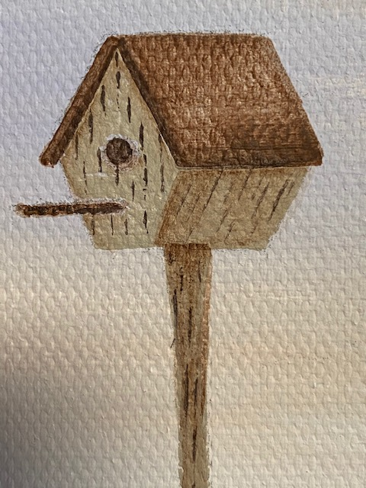
11. Base the birdhouse and post in Driftwood, using the ¼” inch Angle for the house and #2 Round for the post. Base the roof of the house with Burnt Umber and a little Blending Gel. The Blending Gel will keep the paint from being opaque, giving it a look of worn wood. Dry. Add the hole and the perch with Burnt Umber using the #0 Round. Using Burnt Umber and the ¼” Angle, float a shade under the roof, and down the right angle of the house. Shade underneath the house on the post and above and below the male cardinals tail with Burnt Umber. Add wood markings with Soft Black and Burnt Umber with #0 Round. Drizzle some snow on the birdhouse roof and on the perch with Cool White using the #0 Round.

12. Add the brush at the bottom of the birdhouse with Burnt Umber and Raw Sienna using the #0 Round. Add some small dots of color with Brilliant Red and Canyon Orange using the stylus.

13. Add snowflakes with stylus using Cool White and dab in some snow at the base of the brush below the birdhouse.

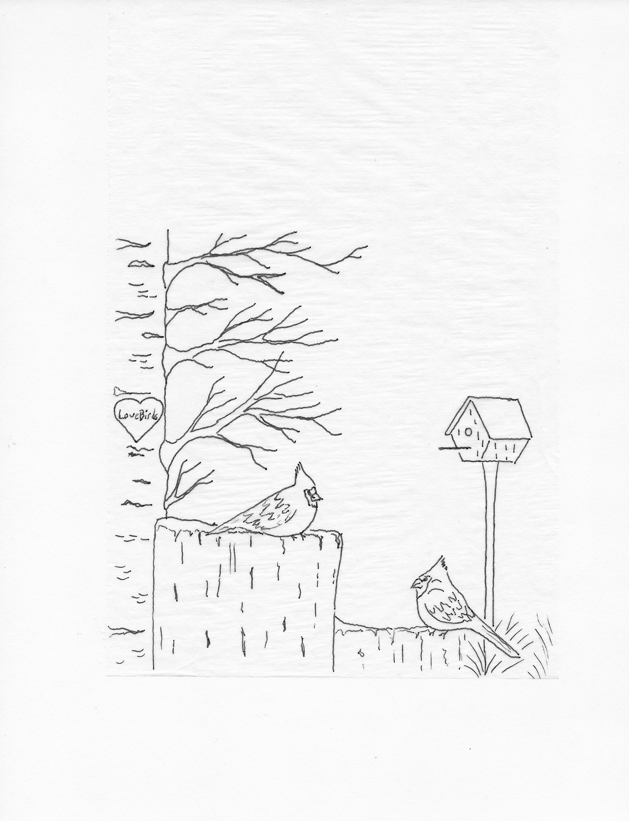
FINISHING TOUCHES
Let your project dry thoroughly overnight. Once completely dry, apply one or two coats of varnish using the ¾ inch Angle Brush. You can purchase an easel to display your painting at your local craft or art supply store. I hope you enjoyed painting this project!

