ZEBRA JACKET
By Margaret Riley
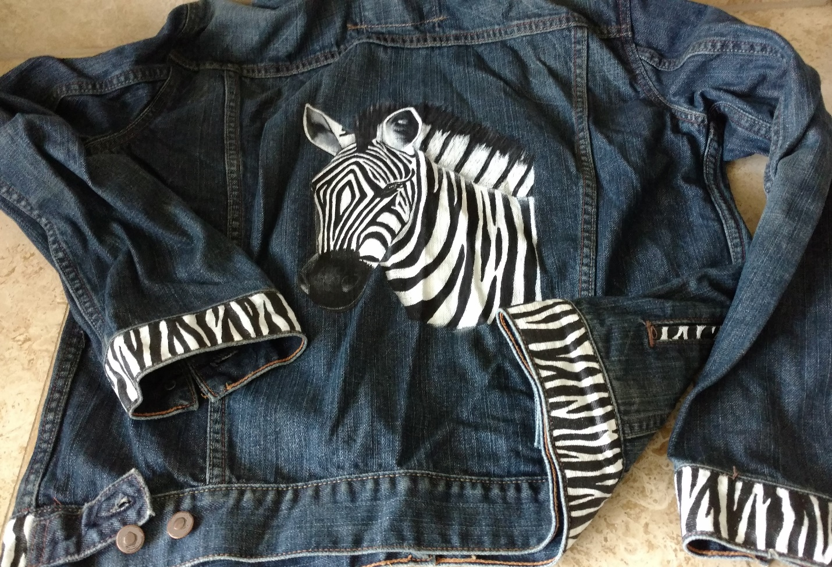
Have a plain, blah, simple jean/denim jacket hanging in your closet? Let’s spruce it up with a zebra theme. Only four bottles of acrylic paint and a masterpiece will be created! These instructions are for both patterns with some slight variation that can be seen in the photos. Each zebra has their own stripes. You can create the stripes as you wish.

SUPPLIES
SURFACE
Jean/denim jacket (or you could do any fabric project such as a pillow, denim purse, etc.)
PAINT
Plaid Fabric Paint
25999 Black
25997 Ganache
25998 Grey Mist
25972 White
BRUSHES
Royal & Langnickel Sunburst Taklon
Series 7300
Flat 1/4", 1/2", and 1”
Ultra-Round No. 4
Series 7050
Liner No. 00
OTHER
Tracing paper and pencil
Red ink pen and blue ink pen
White (for dark backgrounds) and black (for light backgrounds and tracing on stripes) graphite paper
Paper towels
Palette for acrylic paints or a foam disposable plate
Water basin
T-shirt/fabric board or very stiff thick cardboard covered with freezer/butcher paper (wax side out)
Masking tape
Straight pin
Black Identi Pen Permanent Marker
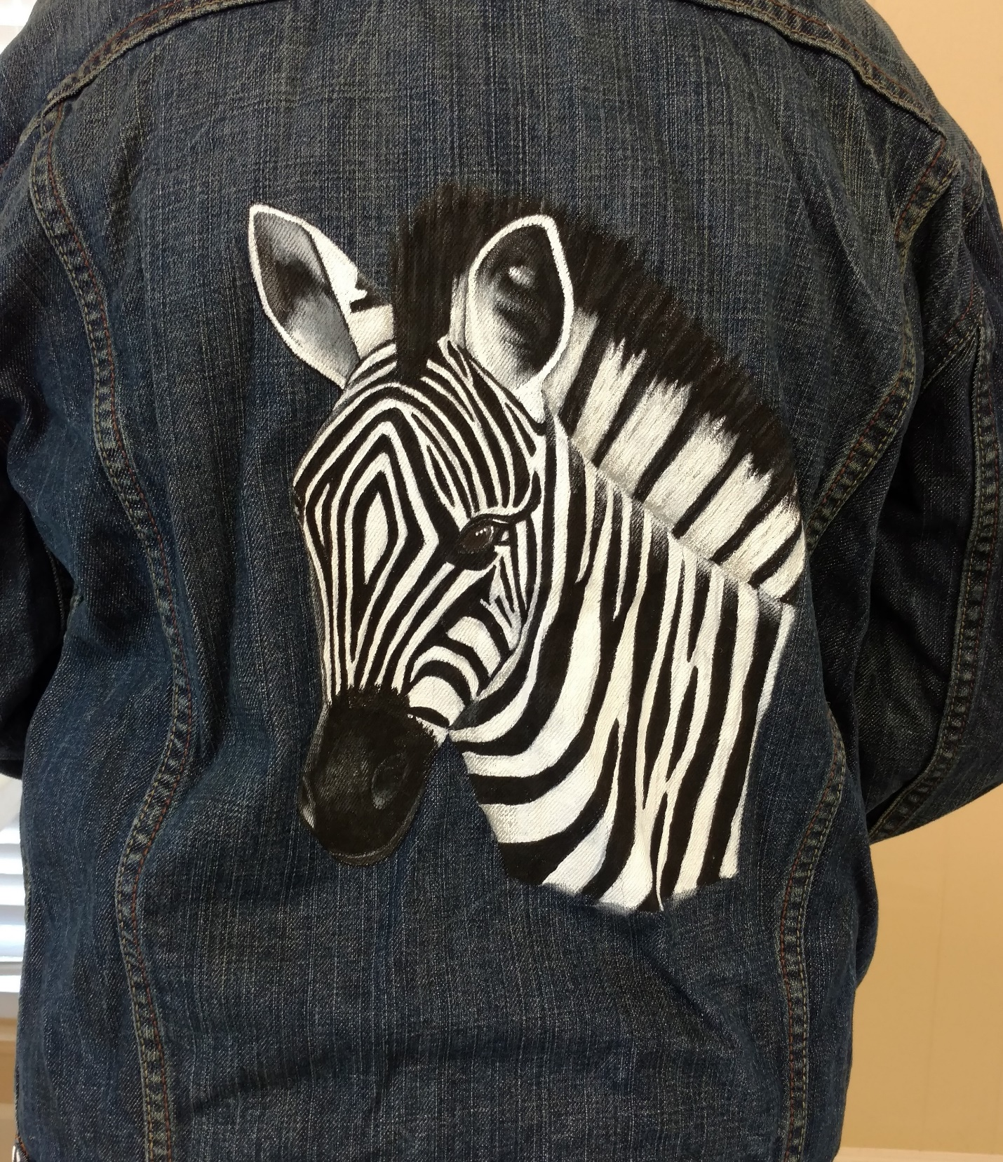
INSTRUCTIONS
*Note: Use brush size to accommodate area that’s being painted unless instructed otherwise.
*If cuffs, bands, and tabs are being painted on a jacket, they will be painted after zebra head is finished.
*Shading is done on the left side and highlighting is done on the right side.
*Stripes on pattern may vary slightly with stripes on project photo. Working on a heavy fabric makes applying the drawn lines difficult. You may have to make some stripes wider and delete some. Stripes close together can be tricky to draw and to paint.
1. Using pencil and tracing paper, trace zebra.
2. If painting on clothing, slip board into item and secure loose ends (sleeves, hems, etc.) with masking tape to avoid getting them accidentally into your paint palette surface.
3. Center pattern on project surface (jacket is on back side) and secure top with straight pin or masking tape.
4. Slide white graphite (if background is dark) under tracing paper and trace outside lines with blue ink pen.
5. Using 1/2” and 1” flat brushes, fill in entire area with White. Allow to dry completely and do a second coat. Allow to dry completely.
6. Place pattern over white painted area and align as close as possible. Pin or tape pattern in place.
7. Slide black graphite under tracing paper and trace all stripes and details with red ink pen. IMPORTANT: Mark a small “X” on each stripe that is to be black.
8. Shading: Using flat brush and Grey Mist, shade on left side of head, ears, and neck. If using the pattern with the head is turned over the neck area, shade under head to cast a shadow onto the front of the body.
9. Paint in all “X” marked stripes in Black.
10. Referring to pattern and photo, paint mane Black and White.
11. Referring to pattern and photo, paint ears Black and White.
12. Paint nose Black with highlighting in Grey Mist. Also, around each nostril.
13. Paint eye Ganache with highlights in White. The left side of the eye will have a touch of Black.
14. Highlighting: Using flat brush and White, add highlight on opposite side of shaded areas.
15. Using liner brush, add small eyelashes in Black or use Identi Pen.

TRIM
1.Using 1” brush, paint cuffs, lower band, pocket trim, and pocket flaps White. Do two coats and allow to dry completely.
2. Using the Identi Pen, create zebra stripes freehand. Make some straight, some curved, some split, and some in a “V”. Look at a photo of a zebra to give you the idea on how their stripes appear.
3. Paint every other strip Black.

Allow project to dry for 5-7 days.
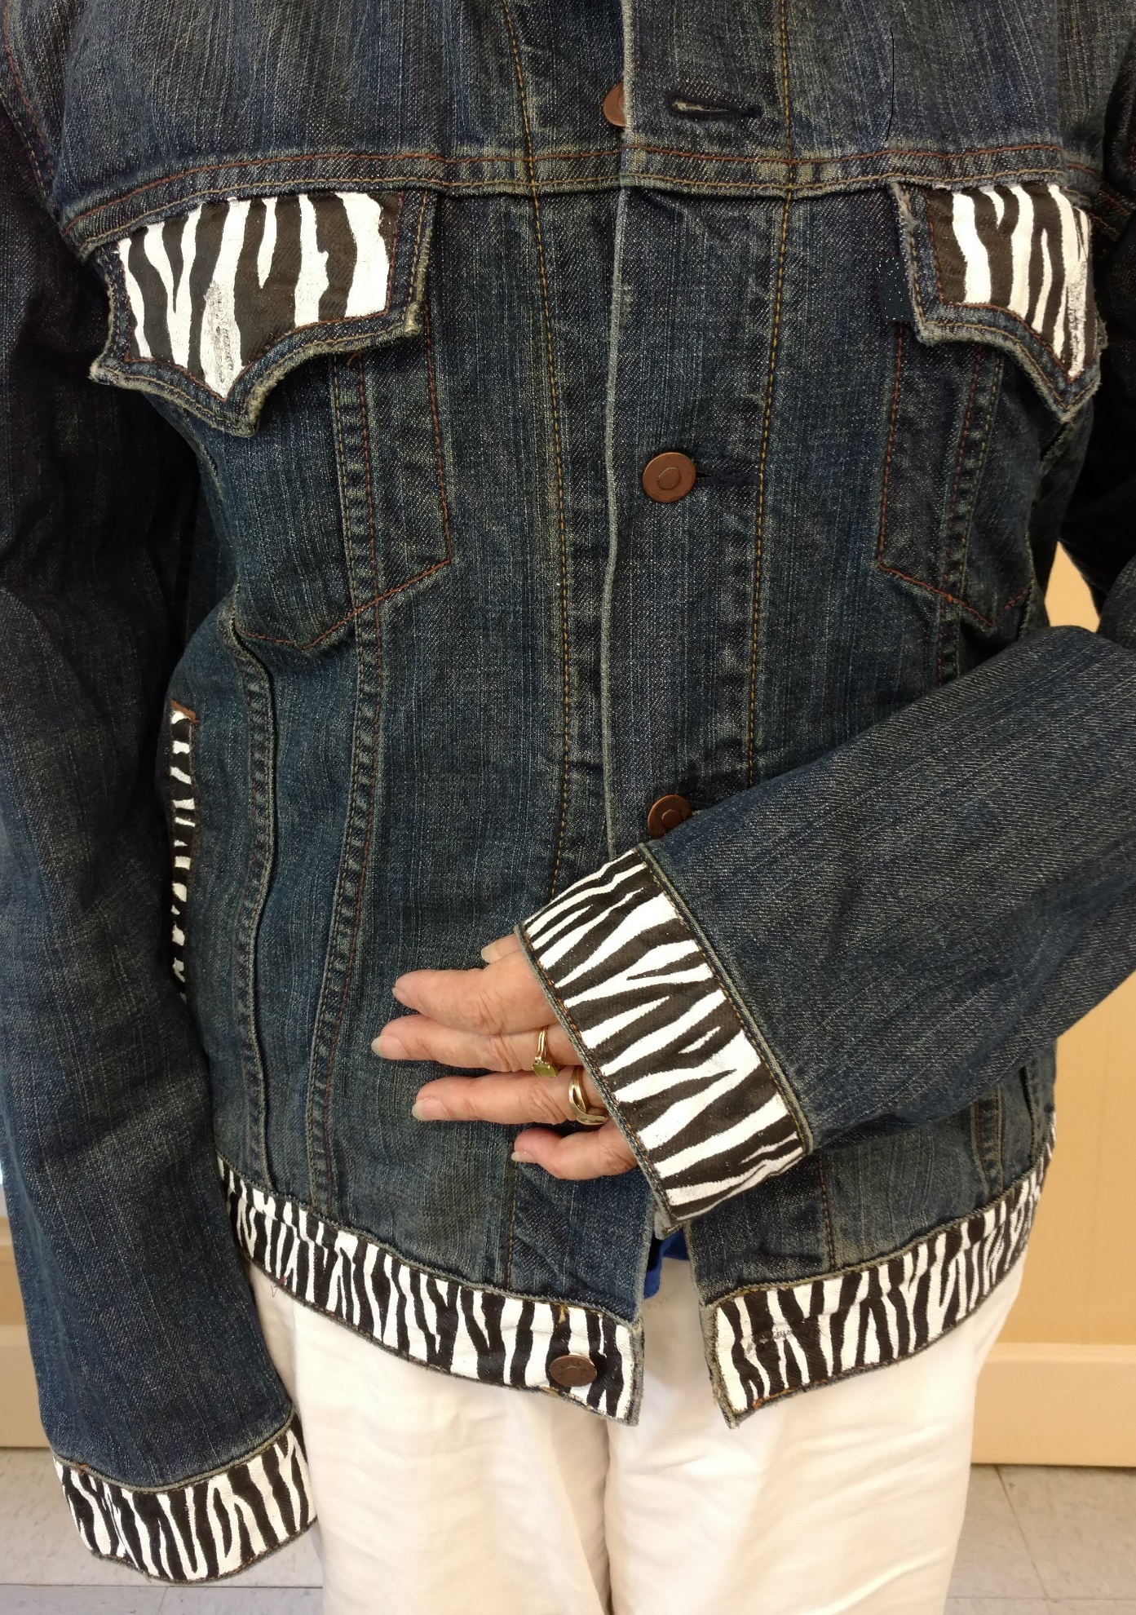
Optional: You can add beads, lace, woven trim, or whatever looks pleasing to you for trim along the yoke in front and back. You can add fabric paint glitter as well. Be creative!

Margaret Riley has been in the craft and hobby industry for almost forty years. During those years, she has owned and operated hobby/craft stores, worked for manufacturers in this industry, taught painting/craft classes, been published too many times to count, been an editor, worked testing new product, is a DecoArt Helping Artist and a Plaid Ambassador, traveled working trade shows/conventions, and much more. She enjoys working with acrylic based paints but does try other mediums. Margaret has two sons, a stepson, and four grandchildren, who are all talented in art!

