HALLOWEEN TAGS
ELPICOUNTRY
ELIANA CASTELLAZZI

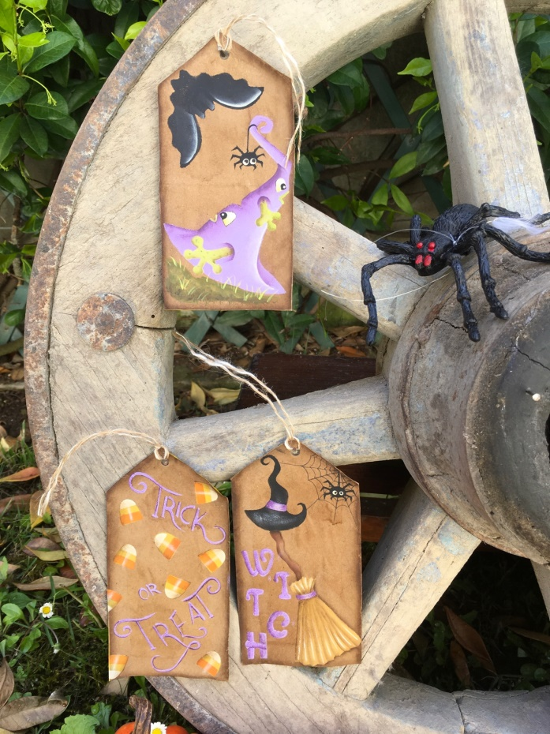

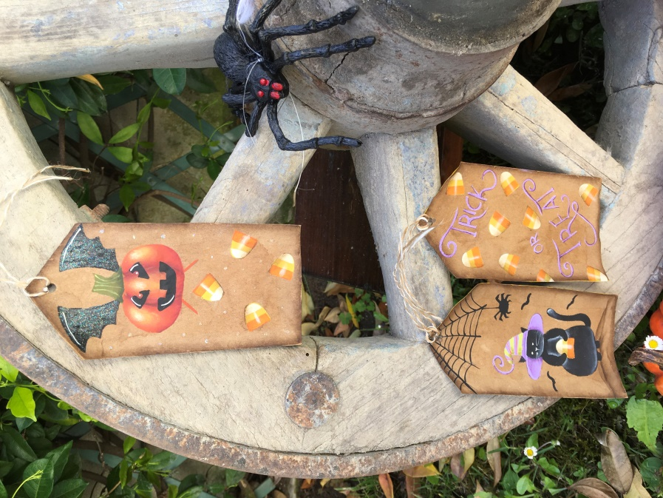

SUPPORT

Tags available in any store or self-made (video tutorial on facebook my profile eliana elpi elpicountry)

AMERICAN ACRILICS DECOART PALETTE

Citron green antique green lamp black buttermilk
canyon orange primary yellow milk chocolate burnt umber
Antique gold purple cow royal purple heritage brick burnt orange glamour dust ice cristal glamor dust lavander

OTHER MATERIALS

Graphite paper, paper palette, tags, Elpicountry Halloween stencils # 05, # 03, # 01, # 02, # 04, instant coffee, makeup sponge, twine.

BRUSHES DYNASTY

Black gold 1/2,, lineer black gold 10/0, half moon dry brush.

PREPARATION

Take the tags to age them with coffee: make a coffee with the soluble and hot water.
Put it in a spray bottle and spray the tags, several times waiting for them to dry between one coat and the other (you can also use the hairdryer)
Shade around the tags with burnt umber

TRICK OR TREAT tag

With the Elpicountry Halloween # 01 stencil go and write on the tag with purple cow.
With a lineer, outline the letters using royal purple, then apply a coat of glamor dust lavander all over the writing.

With the Elpicountry Halloween # 05 stencil go and make the sweets first with the one with their shape and primary yellow. When dry, take the second stencil and make the lower stripe with canyon orange and the upper one with buttermilk.
Shade on the left of the sweets with burnt umber and then with buttermilk a dry brush make the light point in the center.

WITCH tag

With the Elpicountry Halloween # 01 stencil go broom with a hat.
First the hat with lamp black, then the broom handle with milk chocolate, now the broom with antique gold.
Highlight the brim of the hat with buttermilk a dry brush.
Draw the band and paint them with purple cow, shade left and right with royal purple. Give the band a coat of glamor dust lavander.
Shade the broom handle to the left, under the hat and above the broom with burnt umber. Highlight dry brush with antique gold.
Shade the broom with burnt umber to form the bristles. Highlight with a lineer and buttermilk.
The band is made like that of the hat.

With the Elpicountry Halloween # 02 stencil make the word witch with purple cow, shade on the left with royal purple. When dry, apply glamor dust lavander over the entire writing.

FROG tag

With the Elpicountry Halloween # 03 stencil make the hat with purple cow and the bat with black.
Shade on the left with royal purple on the right highlight with buttermilk.
With the stencil make the eyes with buttermilk, shade with citron green, make the pupil with black and the light point with buttermilk.
Paint the mouth with citron green.
With the stencil paint the paws, shade on the hat where they come out with royal purple, shade the paws with antique green, make dots with citron green.
Paint the puddle with a mix of antique green and burnt umber, make the blades of grass with citron green.
The spider is done with the Elpicountry Halloween # 02 and black stencil, paint the eyes with a burin and buttermilk.

The bat is highlighted on the wings with buttermilk.

CAT tag

With stencil # 04 and black paint the cat. Highlight the belly, the muzzle down, the legs and the tail with buttermilk.
Make eyes, nose and mustache with buttermilk
With the same stencil make the cat's hat with purple cow.
Shade near the nose and brim with royal purple.
Make the stripes with citron green and shade them on the left with antique green.
Paint the ground with burnt umber under the cat.
The dolcetto is done as in the TRICK OR TREAT tag.
Paint the bats, the cobweb with black.
The spider is made with the Elpicountry Halloween # 02 stencil.

PUMPKIN tag

With the Elpicountry Halloween # 04 stencil, paint the pumpkin with burnt orange.
Draw the central section and paint the division of section with heritage brick.
A dry brush highlight sections first with canyon orange then with primary yellow and then add a touch with buttermilk.
Eyes and mouth gift designed and painted with black give the light point with buttermilk.
The stalk is painted with the stencil and antique green. Line up with citron green and shade the stalk next to the pumpkin with a mix of antique green and black.
The pumpkin wings are done with the same stencil # 04 and black.
Make the light point with buttermilk and give on both wings with glamor dust ice cristal.

The treats are made with the Elpicountry Halloween # 05 stencil as in the first tag.

I had a lot of fun making these tags, have fun too!
You can make tags also with drawing in this pattern.

You can buy my halloween stencil and other stencil on my store etsy ELPICOUNTRY

Put your tags made with my stencils or drawing on the Elpicountry page on fb and on the Elpicountry friends group.
You can also follow me on my YouTube channel Elpicountry eliana

