Painting World Magazine Designer Newsletter
Hello and welcome to the first newsletter for Painting World Magazine & Blog designers, both new and established. The goal of the newsletter is to encourage you as both an artist and a designer. Look for articles intended to assist you in your creative endeavors.
We want your best!
We highly encourage you to submit your very best work. Our editorial staff will look at many submitted designs, they then go through a selection process. The better your work, the better your chance of being published. We have recently added retail magazine distribution to our subscriptions and online presence. This, along with more submissions, makes giving your best all the more important. *Please note that we cannot accept free-hand writing on designs. Please use a stencil or tracing of fonts in your designs.
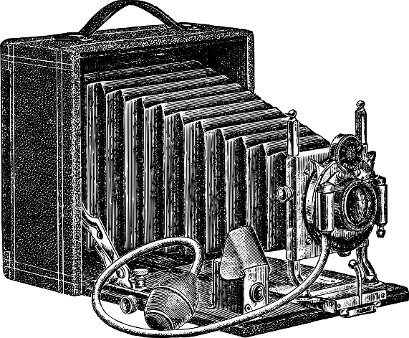
Photographing your work.
The digital age has created a new way to submit photos for magazines. Where once you would have sent your projects to us to photograph, now you are the photographer. We realize not everyone has a fancy camera but with today’s smartphones taking good photographs is easy. Make sure you send high-resolution photos. The higher the resolution the better the photo will appear in print. Send the photos as actual size. This is an option on phones and the computer. That gives the maximum resolution. Make sure to use good lighting that doesn’t reflect on your piece. Avoid flash photography. *Tip- Sometimes taking your final photos before adding a finish gives you a sharper image. You can take and submit many photos of your project, from step-by-step (if needed) to the finished project. For these photos, a white or dark background will work well. The less-is-best formula works here for backgrounds. Take clear, concise straight-on photos whenever possible. Once you have taken these photos, it is time to take some staged photos.
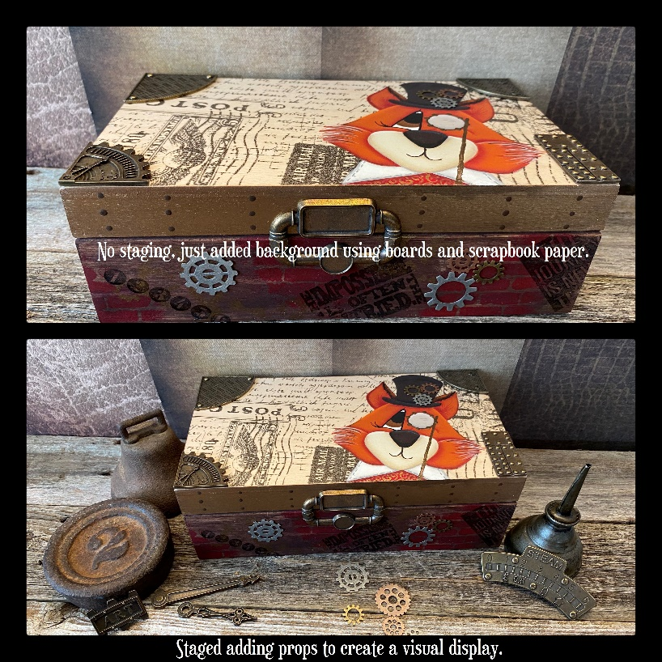
Photos & Design ©2020 Oil Creek Originals
How to stage your design in photographs.
The idea of staging is to place your project into a setting so readers can get an idea of how it would display in real life. The idea is to sell your design! Just as a retailer creates displays in a store window, you want to create a display in your photograph. Your artwork should be the focus with items added in the background and/or foreground. Use items that compliment your design but do not distract from it. Make sure to take multiple photos at different angles. Be sure your piece is completely displayed. You don’t want to hide it behind something.
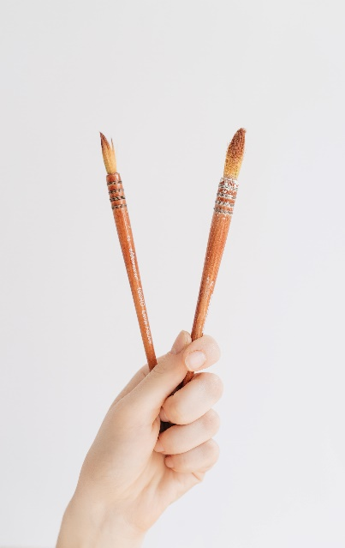
Stress relief for designers.
Even decorative painting designers can be stressed. Deadlines seem to put the rush on your painting and everyday life always puts in an appearance, from the phone ringing to family ‘emergencies’, there is always something to interfere in the creative process. Fortunately, painting itself can help relieve stress. Sometimes, simply taking a break can help. Go outside, get a breath of fresh air. Take a walk. I’ve also found setting a schedule and being in the studio with no phone helps. For some, music soothes. For others, listening to podcasts or books on tape while painting does the trick. I know of some who ‘listen’ to TV or movies while painting. What’s your go-to method for stress relief?

Useful Links & Emails
Submissions Information, Painting World Magazine - https://www.paintingworldmag.com/submissions
Submissions – PWM Blog – pwmblogeditor@gmail.com
Editor, Kole Hunt – Painting World Magazine – editor@paintingworldmag.com
Editor, Diane M Kellogg – PWM Blog – pwmblogeditor@gmail.com
Viking Designer Programs – vikingdesignerprograms@gmail.com

Our new editorial calendar.