MARE
by Anita Campanella

ABOUT ME:
I live in a small village in Puglia, on a hill near the sea, located in southern Italy. I have been painting since I was still a child. I have attended many painting courses with famous international artists: Bobbie Takashima, Kim Hogue, Maxine Thomas, Holly Hanley, Jamie Mills Price etc. But I must admit that my absolute teacher is Alessio Meggiato who still encourages me and follows me with many tips. I have my own line of patterns that are present on various sites in the USA. I regularly exhibit at craft fairs in my country. I have the wonderful opportunity to collaborate with Painting World Magazine and I'm really very excited. Welcome to my world.

SUPPORT:
fabric bag 15”x 18”
Enlarge the drawing +150%

PAINT BY DECOART AMERICANA :
Dark Chocolate DA065, Open Water DA374, Raw Sienna DA093, Burnt Sienna DA063, Marmaid Tail DA373, Uniform Blue DA086, Bleached Sand DA257, Berry Cobbler DA370, Vintage PinkDA369, Soft Black DA155, Avocado DA052, Green Lagoon DA372.

BRUSHES BY DYNASTY:
Dry Brush series 200 , n. 6
Mop series 400, n. 3/4 , 1/2
Black Gold Round n.4
Black Gold Liner n. 10/0 , 20/0
Black Gold Angle n. 1/2 , 1/4
Blue Ice SC32B n.14

MISCELLANEOUS SUPPLIES:
Ball Stylus
Tracing paper
Black graphite paper
Paper palette
Decoart Fabric Painting Medium DAS10

Preparation:
Wash the bag with mild detergent and let it dry well. Once dry, mix well in a small glass jar with Water and Decoart Fabric Painting Medium 1: 2. Make sure that the jar has a lid with a good closure, so that you can put it in the fridge if your mixture is in excess. Trace the drawing with black graphite paper underneath and with the help of a Stylus.
Wet the whole area of ​​the seaweed with the mix of Medium with an angular or flat brush, which will be the same that we will use for the shadows. The seaweed have the shadow that runs along their length with a brush mix of Green Lagoon, Avocado and Mermaid Tail. Alternate these colors, mixing them together in different proportions so as to have seaweed with different shades. For example, those located behind, will be darker, going to take in the mix, more Avocado. Those positioned forward will be lighter, so we will fish and mix with a brush, more Green Lagoon. Be very free in this. If necessary, position the Bleached Sand in the center and blend outwards. The seaweed details are with the Liner and Avocado. 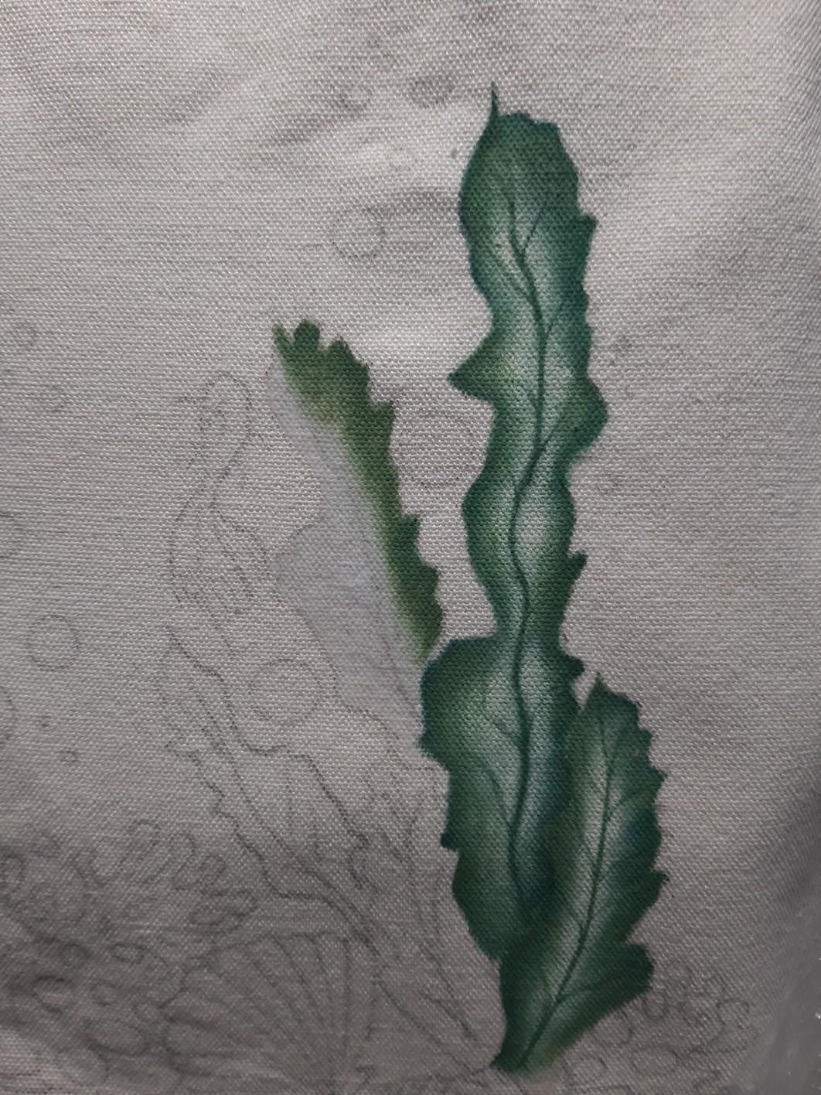Leave to dry. Among the various steps, when the work is dry, if necessary perform Dry Brushes to reinforce the areas in light with the appropriate brush and Bleached Sand. With the Liner and Bleached Sand are the subtle veins of the seaweed. 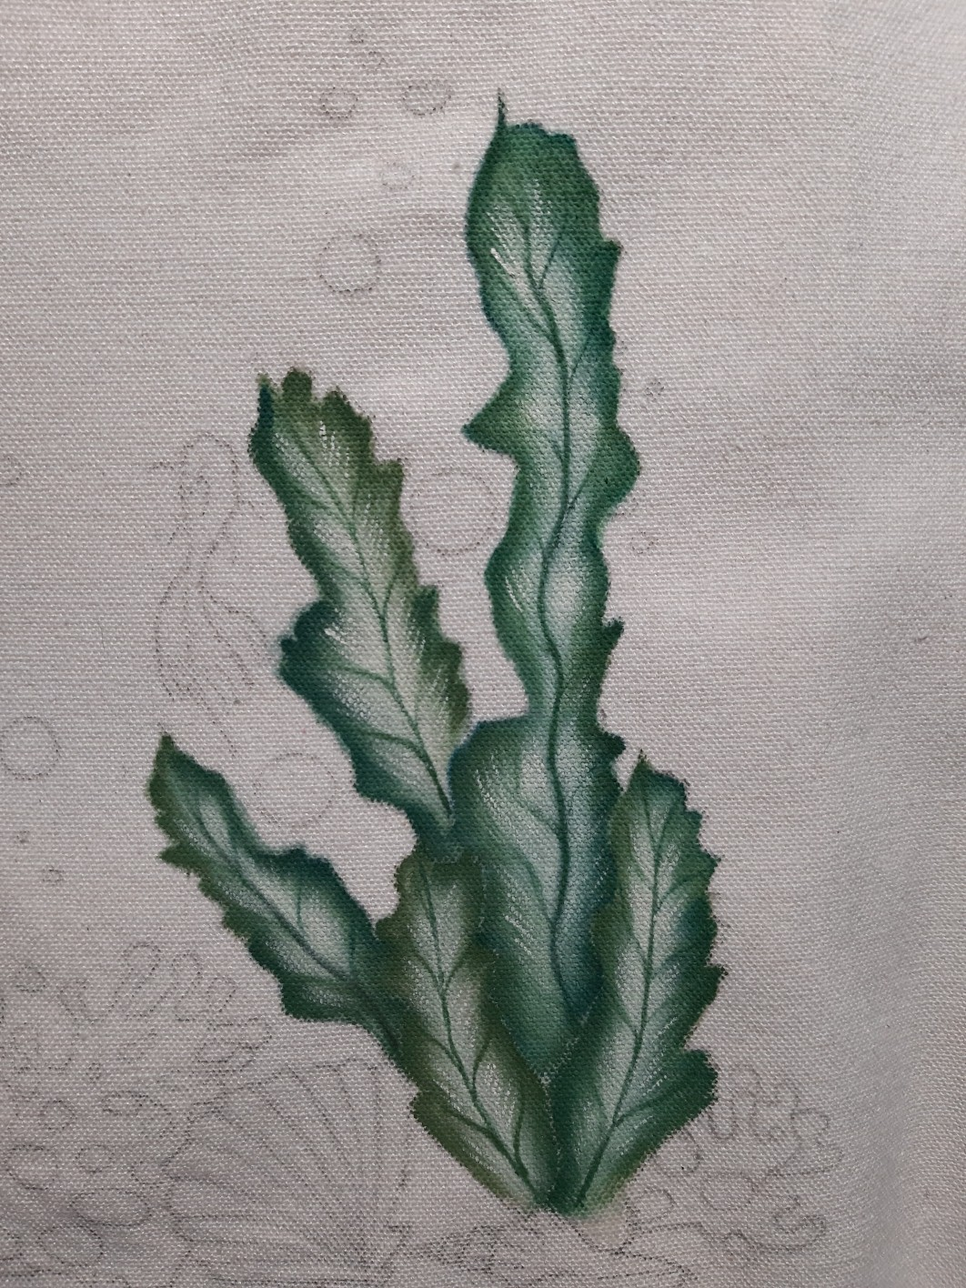The shadows at the base of all seaweed is with Soft Black. (Moisten the area with water first)
Moisten the coral area with the Medium mix, (Continue one coral at a time) and follow with the base with Bleached Sand. The shadows are Berry Cobbler. (do not let the color dry between the base and the shade. Run the shadows when the base color is still fresh) Leave to dry. The lights are with the Liner Brush and Bleached Sand 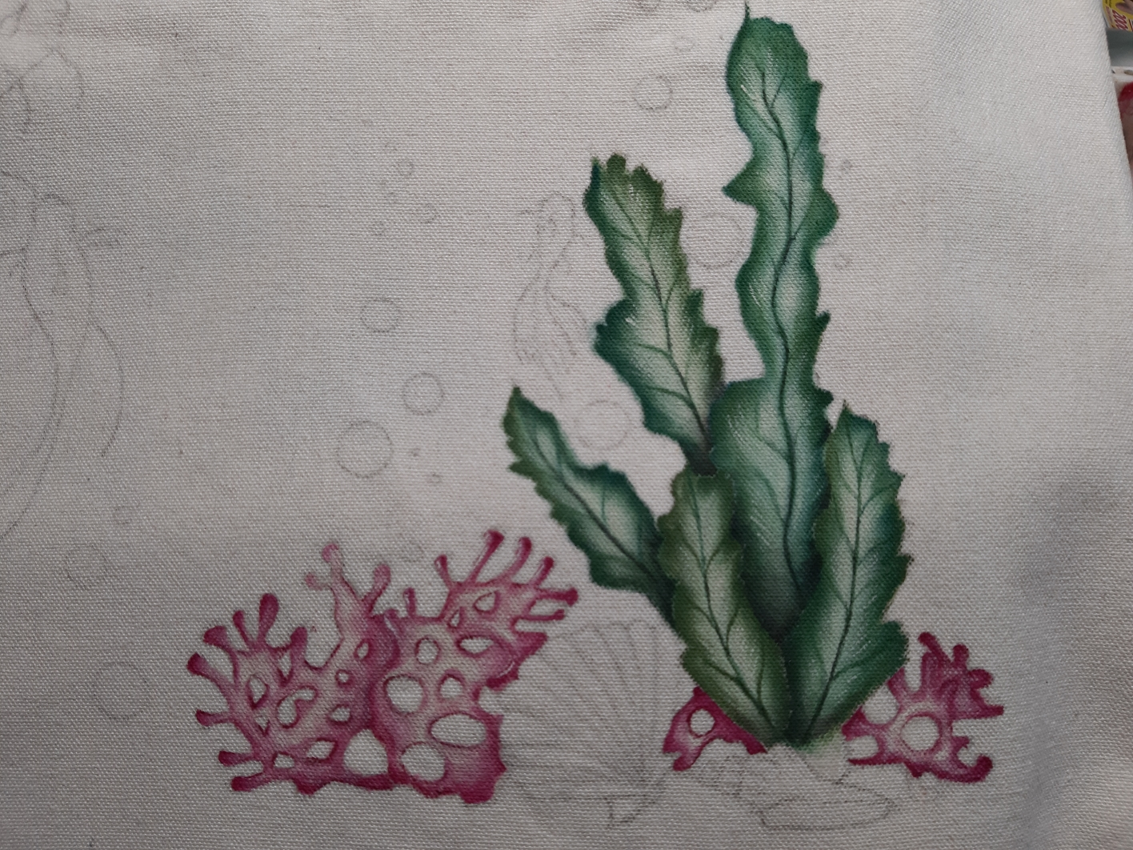
The shell on the left is first moistened with the Medium mix, immediately after it has a base with Bleached Sand. When the color is still fresh, follow the shadows with Burnt Sienna. With the same cutting brush positioned and Uniform Blue are the details of the shell. If necessary, highlight the details of the shadows with the Liner and Burnt Sienna. With the Liner and the Bleached Sand are the lights. The shadow at the base is Dark Chocolate.
Moisten the area of ​​the shell on the right. The basis is Bleached Sand. When the color is still fresh, follow with Raw Sienna for shadows. Deepen the shadows with Dark Chocolate. Place spots of color, according to your taste with Berry Cobbler. If necessary, position the lights with Bleached Sand. 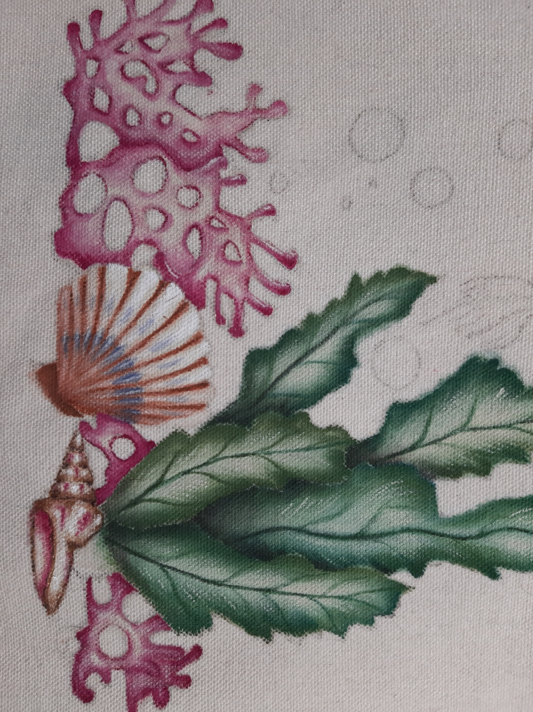Let dry well.
Only after having dried all the work done previously, can we continue with the background at the base. Moisten the entire sand area with water. Wet even beyond the perimeter, thus avoiding the formation of stains. Prepare a mix of Water and Raw Sienna 3: 1 on the Palette. With an angle or flat brush, place the color to create the sand. Continue step by step, with little color. If necessary, wash the brush and blend, trying to pull the color from one side to the other. With the Bleached Sand are the areas in light. Leave to dry and repeat if necessary.
The fish have a base with the mix of Medium and then with Vintage Pink. Pull the color to outline the tails. 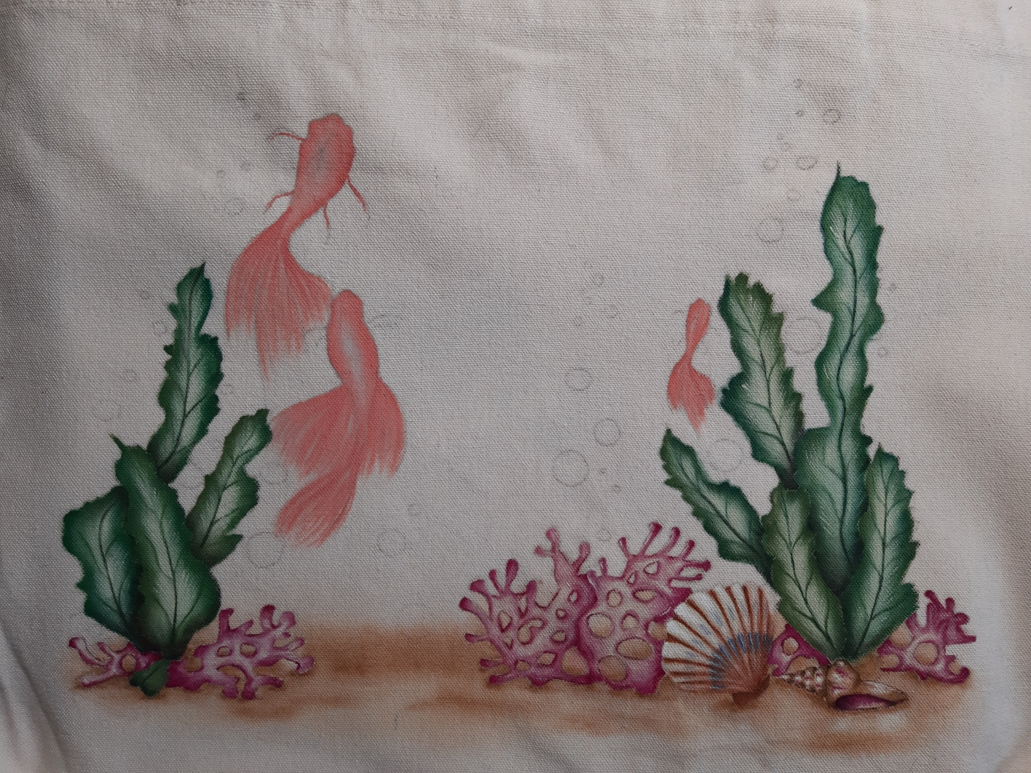The shadows are with Uniform Blue. The light is with Bleached Sand. Leave to dry. The details are with the Liner and the Bleached Sand, then with Uniform Blue. With Stylus and the same colors are the light points. Leave to dry well.
With the large brush n.14, moisten the whole area of ​​the sea with water. Prepare a mix of Water and Open Water 3: 1 on the Palette. Proceed as for the sand previously. Dry and repeat the operation if necessary. Leave to dry. 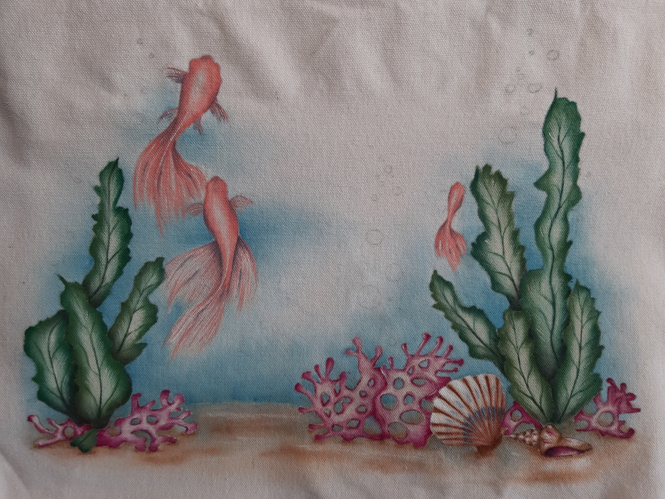
The bubbles have a shadow at the base, first with Open Water and then with Uniform Blue. The light along the top is with Bleached Sand. 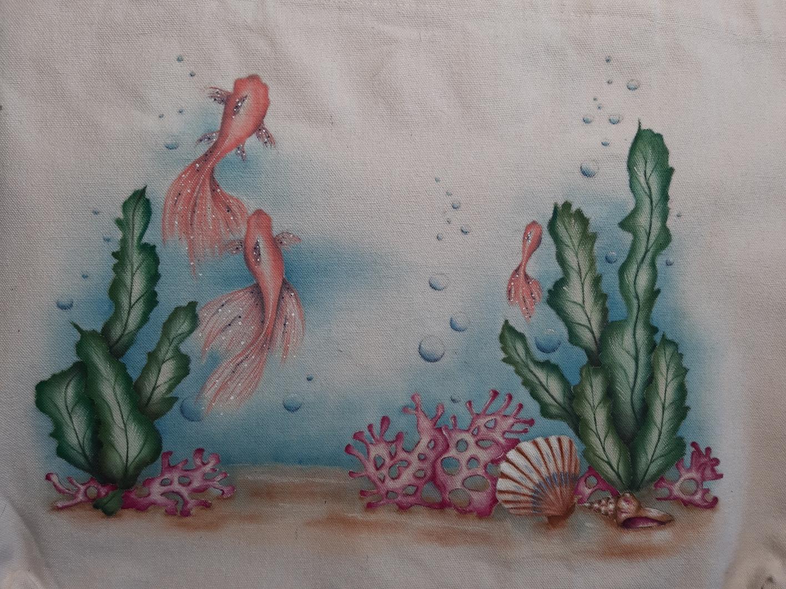Let dry well.
Iron inside out (no steam) to fix colors.
Happy Painting
