Spring Nest
by Vera Collier 2020
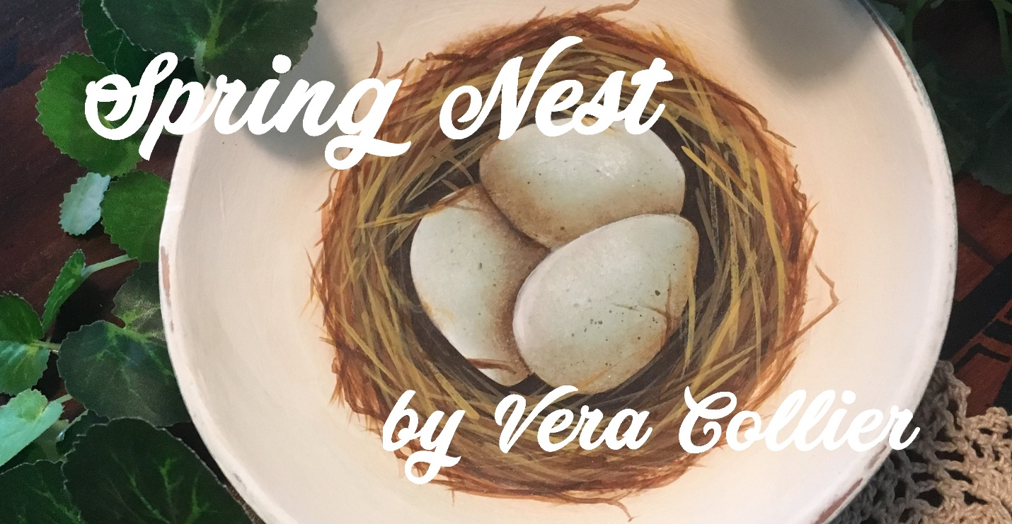
I painted this project in a wood salad bowl that I picked up at a garage sale. However, the design can easily be adapted to many different surfaces.

Supplies

Surface
6” diameter wood bowl

Paints
Decoart Americana
Asphaltum
Blue Mist
Golden Straw
Honey Brown
Milk Chocolate
Soft Black
Warm White

Brushes
10/0 liner
1/2” wash
#2 and 4 rounds
1/2” angular shader or your favorite shading brush
Your usual acrylic brushes. (Unless specified, use the best brush for the area you are painting)

Supplies
Decoart Americana DuraClear Matte Varnish
Decoart Americana All Purpose sealer

Preparation
Sand, seal and sand the bowl. With the 1/2” Wash, basecoat the inside of the bowl with Warm White. I painted the outside with Blue Mist, but you can also paint it Warm White or any other color in the palette. It’s entirely your preference.
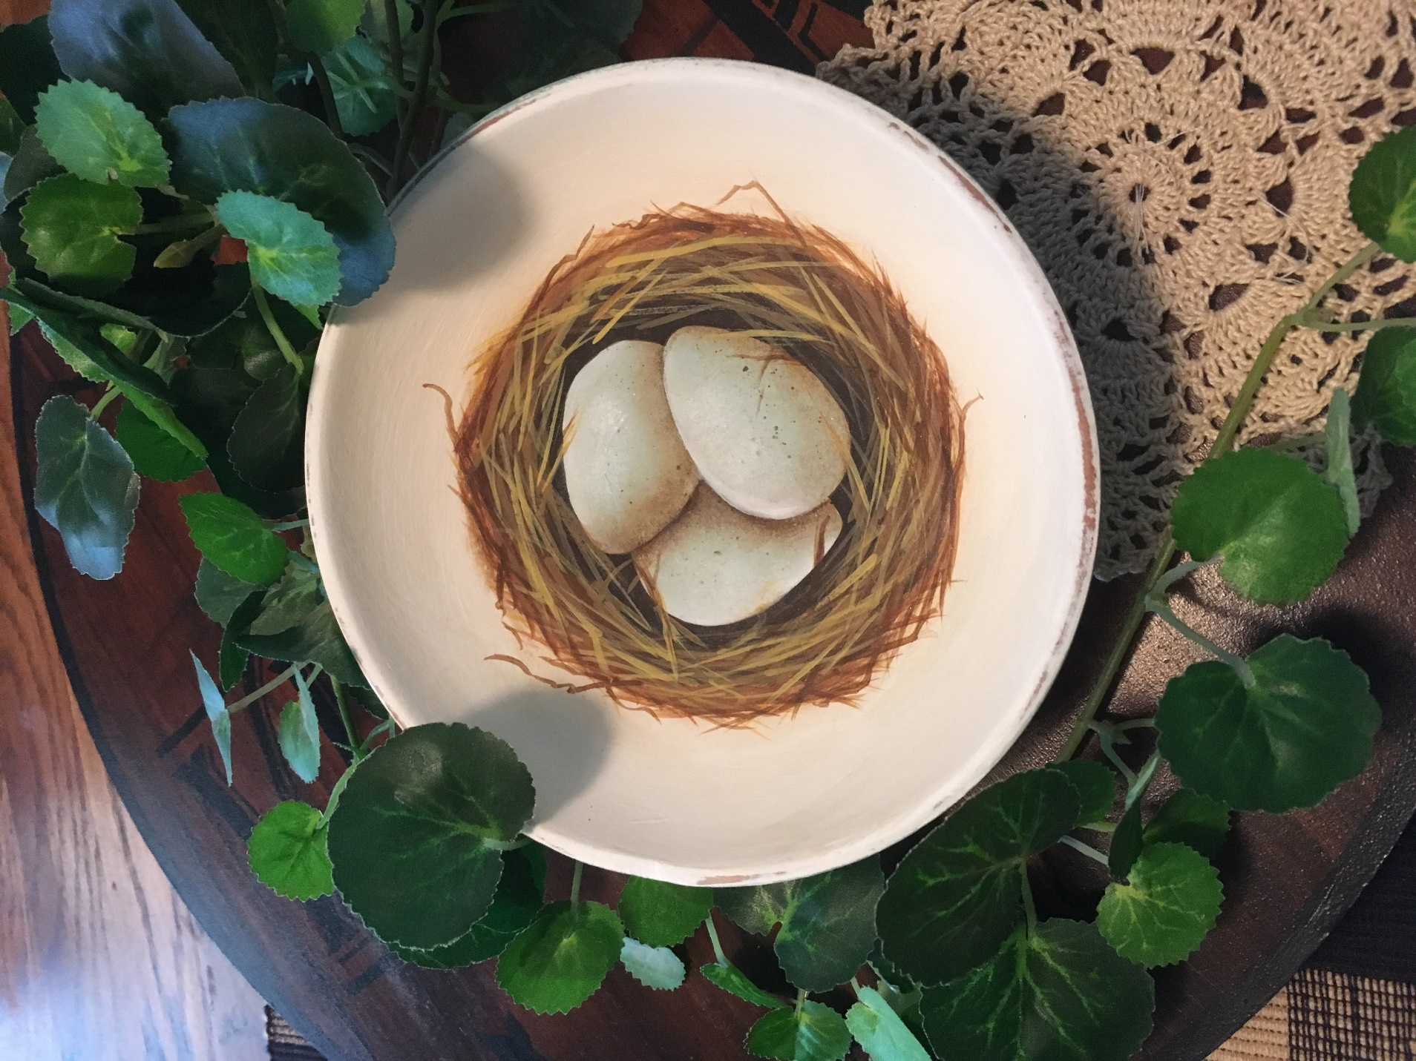

Painting instructions:
Trace the outline for the nest in the center of the bowl. Using your #4 round, loosely base in the nest with Asphaltum. Don’t worry about getting opaque coverage, we will be applying many coats over the top of this one.

Once the Asphaltum is dry, trace the three eggs in the center. Basecoat the eggs with a 1:1 ratio of Blue Mist and Warm White. You want a very pale blue color.
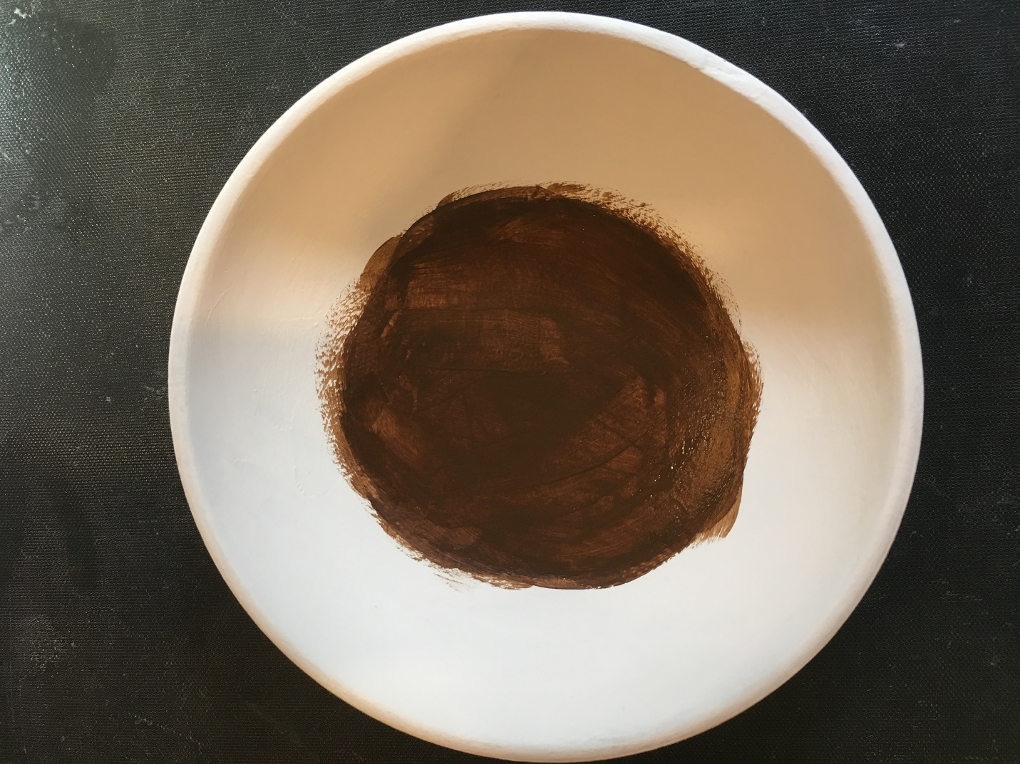
With masking tape, mask off the area around the nest to protect the paint. Lightly spatter the eggs with thinned Ashphaltum. I go old school and use a toothbrush to spatter, but you can use whatever method you are comfortable with.

Remove the masking tape and touch up any of the Warm White where a stray spatter might have hit.

With Asphaltum and your angular shader, shade the eggs where they overlap. The eggs are highlighted with Warm White.
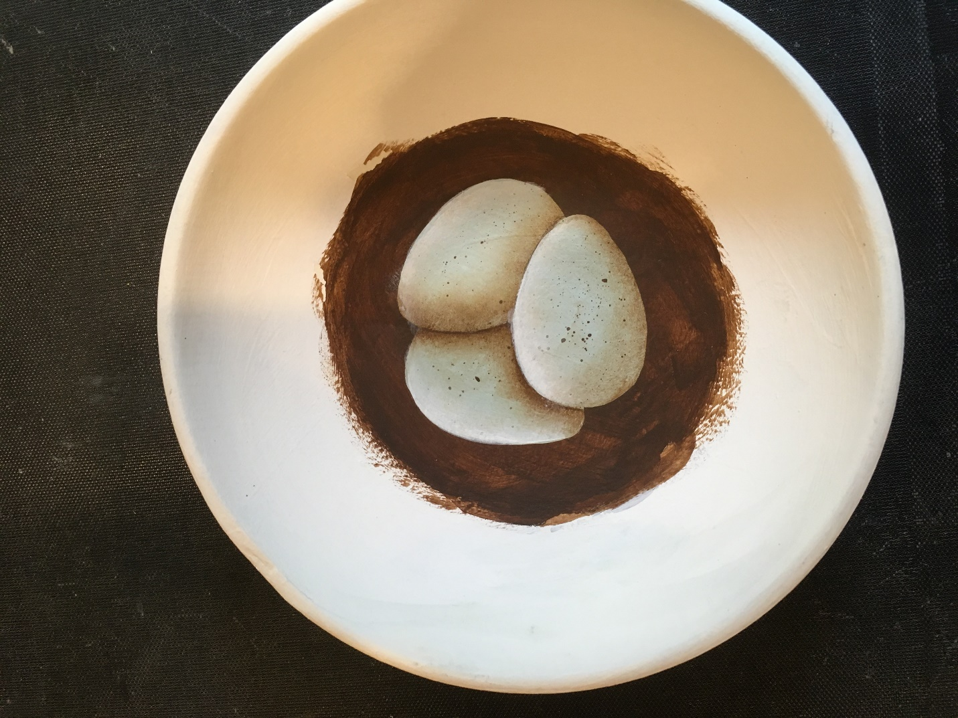
Shade around the eggs with Soft Black.

The nest is painted using a 10/0 liner and thinned paint. Start with Milk Chocolate, then Honey Brown and finally finish up with golden Straw. Build the nest around the eggs by painting the twigs in a criss cross pattern, overlapping and having them going every which way. You can add little squiggles here and there and also, be sure to carry a few twigs across the eggs. I did go back and forth with the colors until I was happy with the way the nest looked.
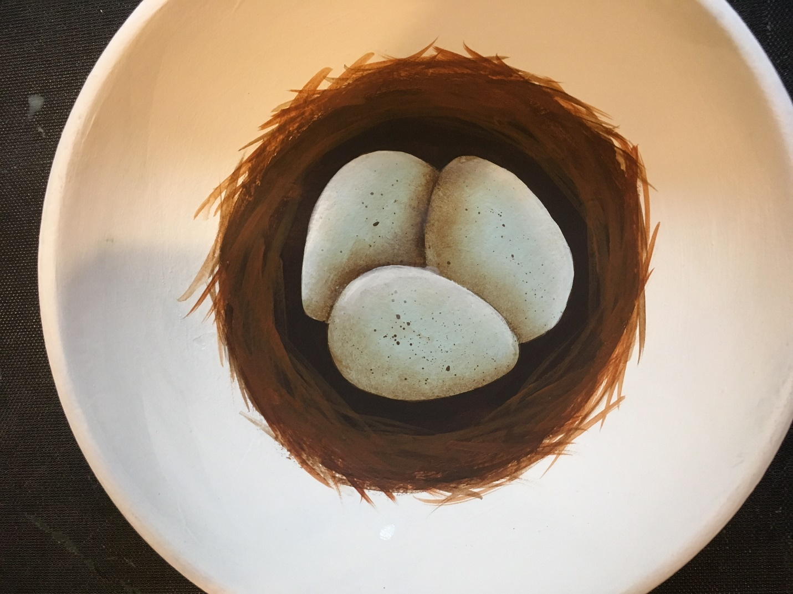
I wanted my bowl to have a little bit of a “chippy” look to it so I lightly sanded the rim. It is up to you if you want to do that or leave it as it is.

Finally apply several coats of Dura Clear Matte varnish to the bowl, both inside and out.

